**Peanut Butter Chocolate Chip Cookies**

**Ingredients**

* **2** **1/4** **c.**

(270 g.) all-purpose flour

* **1** **tsp.**

baking soda

* **1/2** **tsp.**

kosher salt

* **1** **c.**

(2 sticks) unsalted butter, room temperature

* **1** **c.**

(215 g.) packed light brown sugar

* **1/2** **c.**

(100 g.) granulated sugar

* **1** **c.**

(270 g.) creamy or chunky peanut butter

* **1**

large egg

* **1** **Tbsp.**

pure vanilla extract

* **2** **c.**

(340 g.) semisweet chocolate chips, from 1 (12-oz.) bag

Shop Recipe[Powered by Chicory](https://chicory.co/?utm_source=Chicory&utm_medium=campaign+&utm_campaign=chicory-powered-by-button&utm_id=1&utm_term=Chicory+powered+by+button+&utm_content=Chicory+powered+by+button+)

[](javascript:;)

**You’ll Also Love:**

[[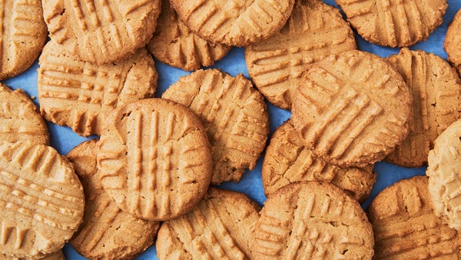](https://www.delish.com/cooking/recipe-ideas/a44889581/peanut-butter-cookie-recipe/?itm_source=parsely-api)](https://www.delish.com/cooking/recipe-ideas/a44889581/peanut-butter-cookie-recipe/?itm_source=parsely-api)

**[Peanut Butter Cookies](https://www.delish.com/cooking/recipe-ideas/a44889581/peanut-butter-cookie-recipe/?itm_source=parsely-api)**

[[](https://www.delish.com/cooking/recipe-ideas/a60874660/girl-scout-tagalongs-recipe/?itm_source=parsely-api)](https://www.delish.com/cooking/recipe-ideas/a60874660/girl-scout-tagalongs-recipe/?itm_source=parsely-api)

**[Girl Scout Tagalongs](https://www.delish.com/cooking/recipe-ideas/a60874660/girl-scout-tagalongs-recipe/?itm_source=parsely-api)**

[[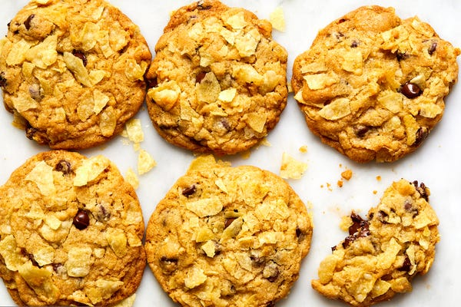](https://www.delish.com/cooking/recipe-ideas/a41559623/potato-chip-cookies-recipe/?itm_source=parsely-api)](https://www.delish.com/cooking/recipe-ideas/a41559623/potato-chip-cookies-recipe/?itm_source=parsely-api)

**[Potato Chip Cookies](https://www.delish.com/cooking/recipe-ideas/a41559623/potato-chip-cookies-recipe/?itm_source=parsely-api)**

[[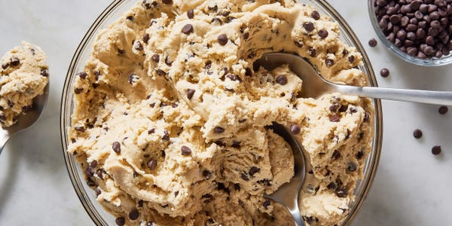](https://www.delish.com/cooking/recipe-ideas/a44566068/best-edible-cookie-dough-recipe/?itm_source=parsely-api)](https://www.delish.com/cooking/recipe-ideas/a44566068/best-edible-cookie-dough-recipe/?itm_source=parsely-api)

**[Edible Cookie Dough](https://www.delish.com/cooking/recipe-ideas/a44566068/best-edible-cookie-dough-recipe/?itm_source=parsely-api)**

[[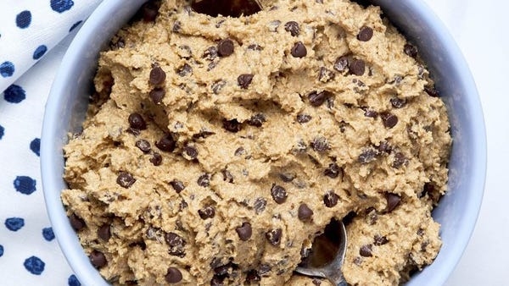](https://www.delish.com/cooking/recipe-ideas/a44880168/shortcut-edible-cookie-dough-recipe/?itm_source=parsely-api)](https://www.delish.com/cooking/recipe-ideas/a44880168/shortcut-edible-cookie-dough-recipe/?itm_source=parsely-api)

**[Shortcut Edible Cookie Dough](https://www.delish.com/cooking/recipe-ideas/a44880168/shortcut-edible-cookie-dough-recipe/?itm_source=parsely-api)**

[[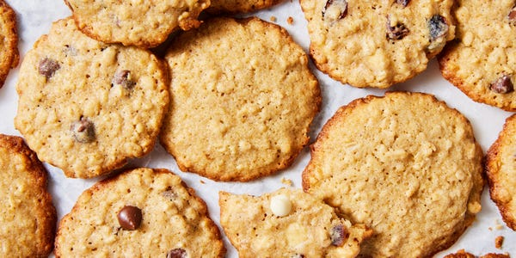](https://www.delish.com/cooking/recipe-ideas/a45586643/thin-and-crispy-oatmeal-cookie-recipe/?itm_source=parsely-api)](https://www.delish.com/cooking/recipe-ideas/a45586643/thin-and-crispy-oatmeal-cookie-recipe/?itm_source=parsely-api)

**[Thin & Crispy Oatmeal Cookies](https://www.delish.com/cooking/recipe-ideas/a45586643/thin-and-crispy-oatmeal-cookie-recipe/?itm_source=parsely-api)**

[[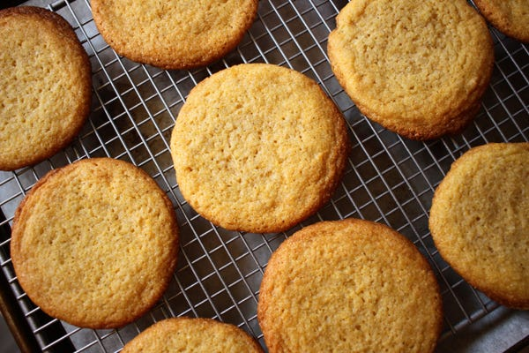](https://www.delish.com/cooking/recipe-ideas/a32906712/corn-cookies-recipe/?itm_source=parsely-api)](https://www.delish.com/cooking/recipe-ideas/a32906712/corn-cookies-recipe/?itm_source=parsely-api)

**[Corn Cookies](https://www.delish.com/cooking/recipe-ideas/a32906712/corn-cookies-recipe/?itm_source=parsely-api)**

**We've got more!**[**GET THE RECIPES**](https://www.delish.com/cooking/recipe-ideas/)

**Directions**

SavePrint

* 1. Step 1Arrange racks in upper and lower thirds of oven; preheat to 375°. Line 2 baking sheets with parchment.
  2. Step 2In a medium bowl, whisk flour, baking soda, and salt. In a large bowl, using an electric mixer on medium-high speed, beat butter, brown sugar, and granulated sugar until fluffy, about 2 minutes. Using a flexible spatula, scrape down sides of bowl and add peanut butter. Beat on medium speed until just combined, about 30 seconds. Scrape down sides of bowl and add egg and vanilla. Beat on medium speed until well combined, about 1 minute.
  3. Step 3Add dry ingredients to egg mixture and beat on low speed until a dough forms, about 30 seconds. Add chips and beat on low speed until combined. Roll 3 tablespoons (76 grams) dough into balls with your hands or a #20 cookie scoop and arrange on prepared pans, with 8 balls on each pan. Refrigerate remaining dough while first batch bakes.
  4. Step 4Bake cookies, rotating pans front to back halfway through, until puffed and edges are golden brown, 14 to 16 minutes (cookies will still be pale on top and fairly soft). Let cool on pan 5 minutes. Using a metal spatula, transfer cookies to a wire rack and let cool at least 20 minutes. Repeat with remaining dough.